Case Study

*A. Modified IEEE-9 test system*

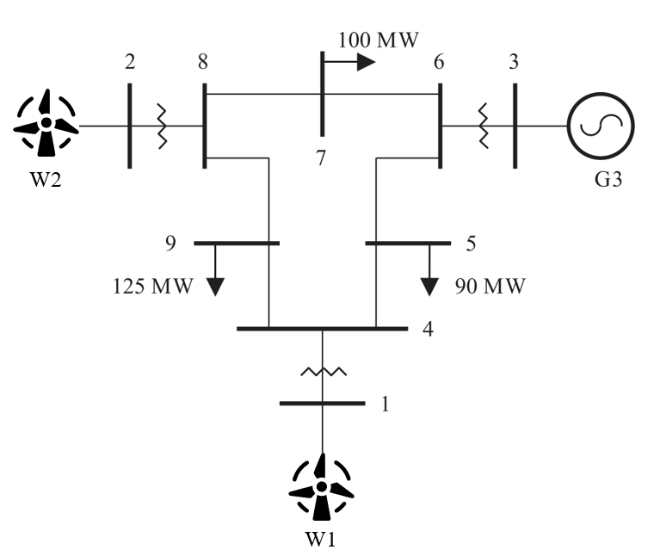

Figure A.1. The modified IEEE-9 test system

TABLE A.I

Capacity of generators and lines of modified IEEE-9 test system

|  |  |  |  |
| --- | --- | --- | --- |
| Generator | Generator capacity (MW) | Line | Line capacity (MW) |
| W1 | 250 | L1-4 | 200 |
| W2 | 300 | L4-5 | 200 |
| G3 | 270 | L5-6 | 100 |
| - | - | L3-6 | 250 |
| - | - | L6-7 | 100 |
| - | - | L7-8 | 200 |
| - | - | L8-2 | 200 |
| - | - | L8-9 | 200 |

TABLE A.Ⅱ

Simulation parameters of modified IEEE-9 test system

|  |  |  |  |  |  |
| --- | --- | --- | --- | --- | --- |
| Resource | number | Time | hour | Range | value |
|  | 72 (3*T*) | *T* | 24 |  | 0.3 |
|  | 24 (1*T*) | *Tr* | 2 | - | - |
|  | 2 | - | - | - | - |
|  | 24 (1*T*) | - | - | - | - |

*B. Modified IEEE-39 test system*

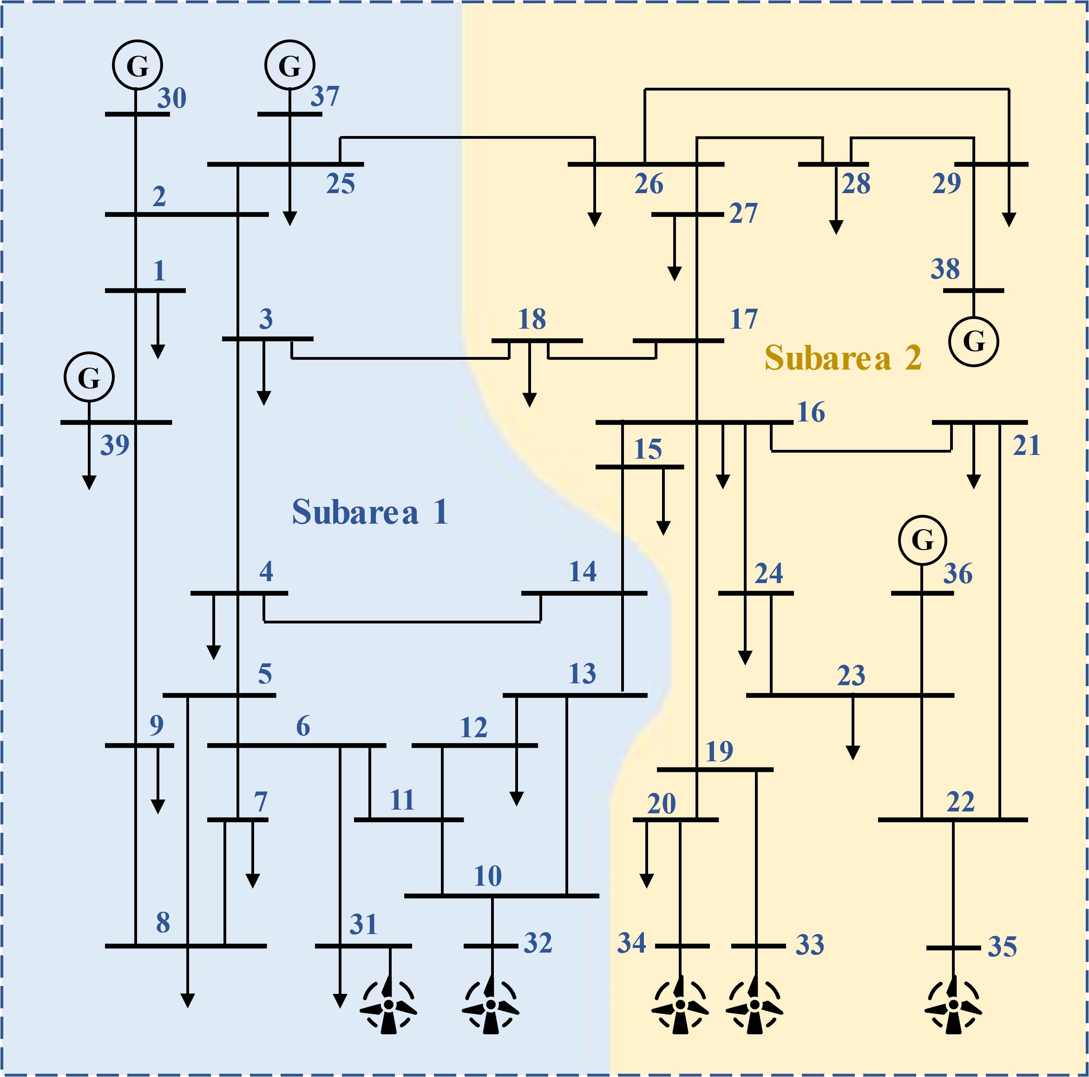

Figure B.1. The modified double-area IEEE-39 test system

TABLE B.I

Capacity of generators and lines of the modified IEEE-39 test system

|  |  |  |  |  |  |
| --- | --- | --- | --- | --- | --- |
| Generator | Generator capacity (MW) | Line | Line capacity (MW) | Line | Line capacity (MW) |
| W31 | 1000.00 | L1-2 | 214.02 | L14-15 | 200.00 |
| W32 | 1000.00 | L1-39 | 200.00 | L15-16 | 341.92 |
| W33 | 1000.00 | L2-3 | 400.12 | L16-17 | 271.16 |
| W34 | 1000.00 | L2-25 | 314.14 | L16-19 | 552.00 |
| W35 | 1000.00 | L2-30 | 300.00 | L16-21 | 401.73 |
| G30 | 1040.00 | L3-4 | 200.00 | L16-24 | 200.00 |
| G36 | 580.00 | L3-18 | 200.00 | L17-18 | 240.82 |
| G37 | 564.00 | L4-5 | 213.22 | L17-27 | 200.00 |
| G38 | 865.00 | L4-14 | 321.84 | L19-20 | 206.40 |
| G39 | 1100.00 | L5-6 | 617.70 | L19-33 | 758.40 |
| - | - | L5-8 | 404.48 | L20-34 | 609.60 |
| - | - | L6-7 | 538.17 | L21-22 | 730.53 |
| - | - | L6-11 | 405.84 | L22-23 | 200.00 |
| - | - | L6-31 | 750.04 | L22-35 | 780.00 |
| - | - | L7-8 | 257.61 | L23-24 | 424.47 |
| - | - | L8-9 | 200.00 | L23-36 | 672.00 |
| - | - | L9-39 | 200.00 | L25-26 | 200.00 |
| - | - | L10-11 | 409.09 | L25-37 | 648.00 |
| - | - | L10-13 | 370.91 | L26-27 | 306.86 |
| - | - | L10-32 | 780.00 | L26-28 | 200.00 |
| - | - | L12-11 | 200.00 | L26-29 | 234.16 |
| - | - | L12-13 | 200.00 | L28-29 | 421.64 |
| - | - | L13-14 | 363.92 | L29-38 | 996.00 |

TABLE B. Ⅱ

Simulation parameters of each area in the modified IEEE-39 test system

|  |  |  |  |  |  |
| --- | --- | --- | --- | --- | --- |
| Resource | number | Time | hour | Range | value |
|  | 48 (2*T*) | *T* | 24 |  | 0.3 |
|  | 24 (1*T*) | *Tr* | 2 | - | - |
|  | 2 | - | - | - | - |
|  | 24 (1*T*) | - | - | - | - |